 CERTIFICATION MANAGEMENT SYSTEM

**PREPARED FOR**

SFDC Training Program

Capgemini Technology Services

**PREPARED BY**

Sourajit Mohanty (46022616)

# Abstract:

Certification Management System is a platform designed using Salesforce software to track and manage Salesforce Certification vouchers issued to all practice members.The application is managed by two types of users-App User and App Admin. App User consolidates data provided by different Employees and creates Certification Voucher requests for each of them which are then sent to the App Admin for approval.Once approved by the App Admin, an active voucher is assigned to the request automatically. Hence provides the employee with a voucher which he/she can use to avail discount while applying for the respective Certification. Emails are sent automatically at every stage to keep users updated about the progress. Also it keeps track of the number of Certified resources in each category.

# Scopes:

1. Inscope: Following is the functionality provided by the system:

There are two categories of people who would access the system: App User and App Admin. Each of these would have some exclusive privileges.

1. The App User can:
   1. Login into the application.
   2. Create/Update employees.
   3. Create Certification request which is then submitted for approval.
   4. Update Certification request’s status to Pass/Fail based on feedback from employee .
   5. View/Search employee, certification, certification request, voucher details.
2. The App Admin can:
   1. Login into the application.
   2. Create/Update certifications.
   3. Create/Update vouchers.
   4. Approve/Reject pending Certification requests.
   5. View/Search employee, certification, certification request, voucher details.
   6. Track Certification and Voucher details.

2. Outscope: The following functionalities have not been covered under the application:

1. The application does not cover automatic Certification-voucher request creation based on Employee’s requirements. It has to be raised manually by App User.
2. Third party applications like sms integrations.
3. After the completion of respective exam, Employee’s pass/fail status is not automatically updated in the system. It has to be done manually by the App User based on the feedback received from the employee.

# Class Diagram:

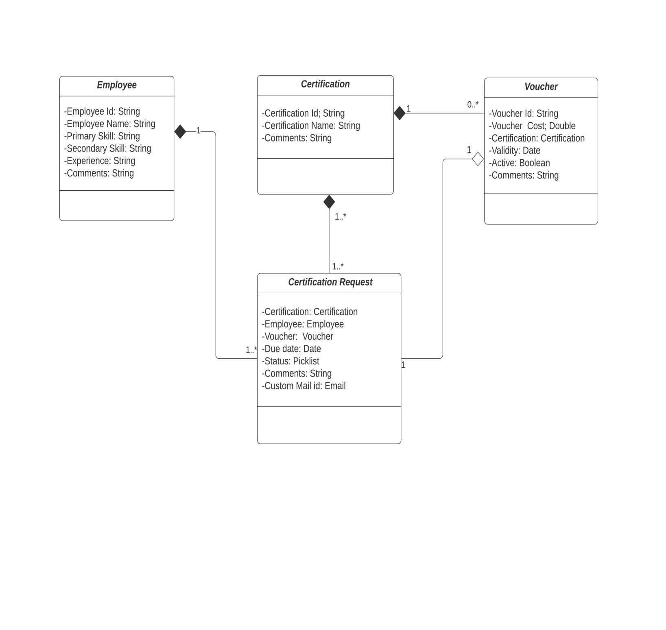

Fig 1.1-Class diagram

# Sequence Diagram for User:

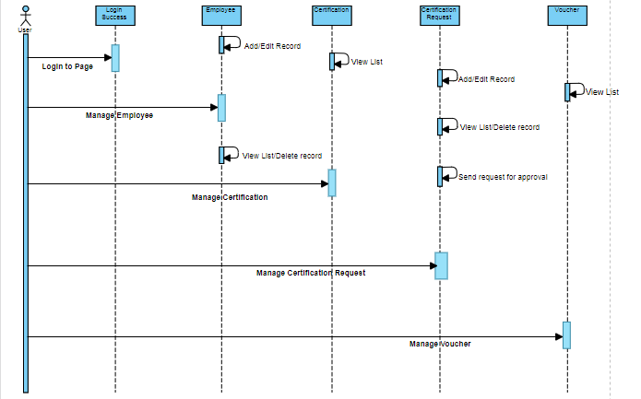

Fig 1.2-Sequence Diagram for User

**Sequence Diagram for Admin:**

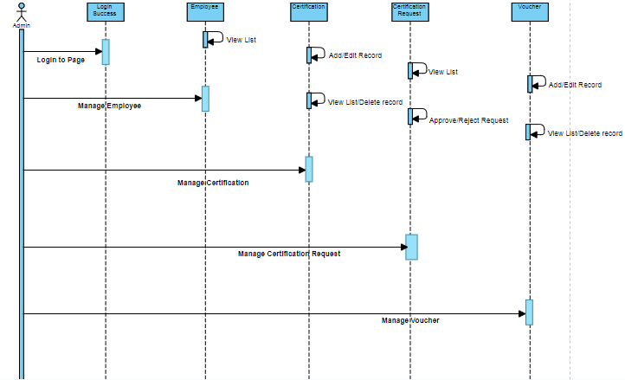

Fig 1.3-Sequence Diagram for Admin

**Activity Diagram for User:**

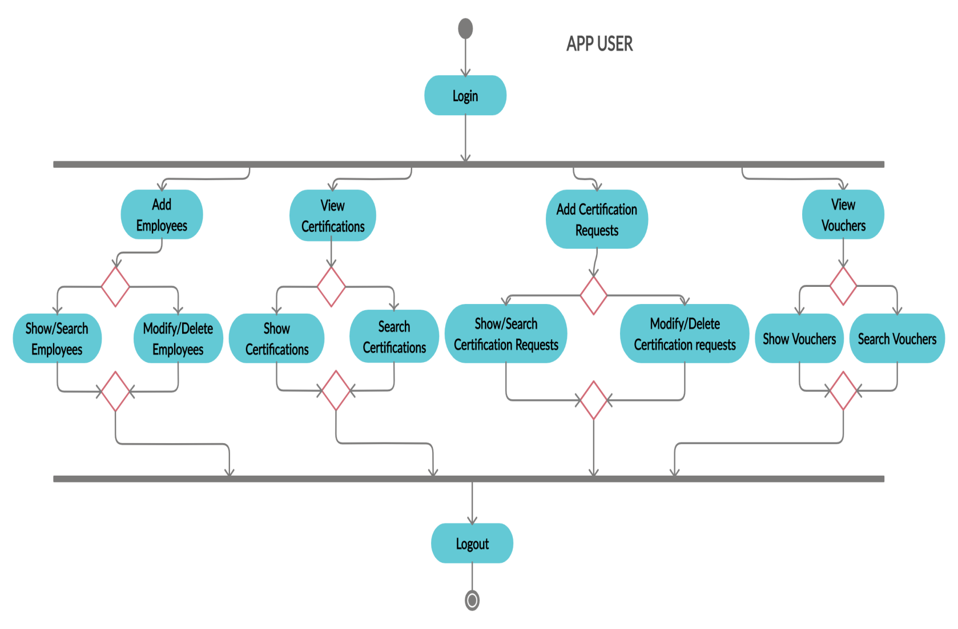

Fig 1.4-Activity Diagram for User

**Activity Diagram for Admin:**

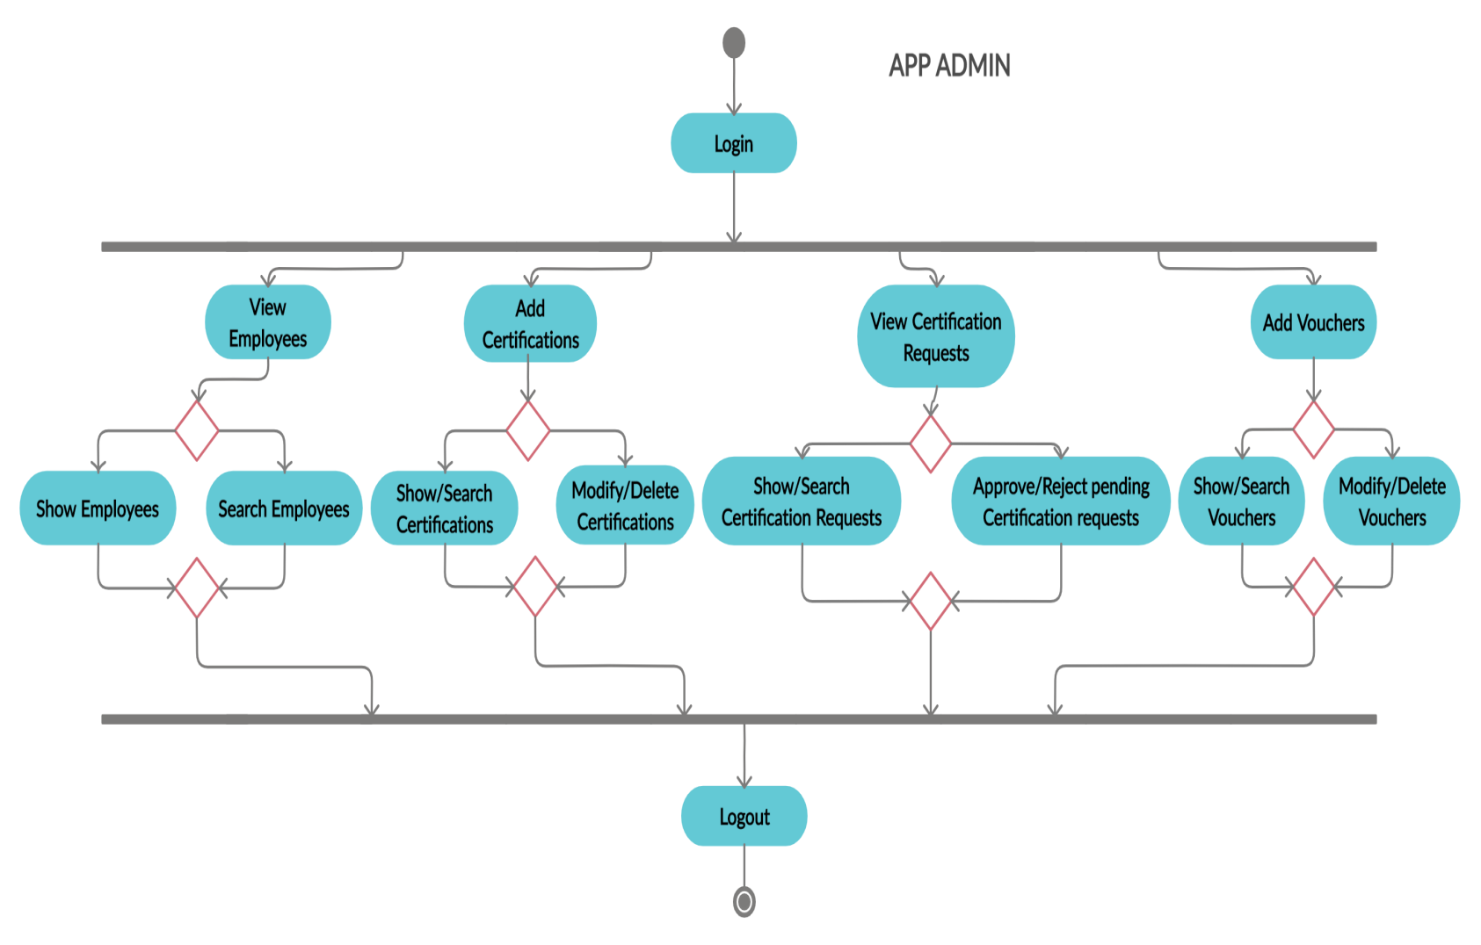

Fig 1.5-Activity Diagram for Admin

**Flow Chart:**

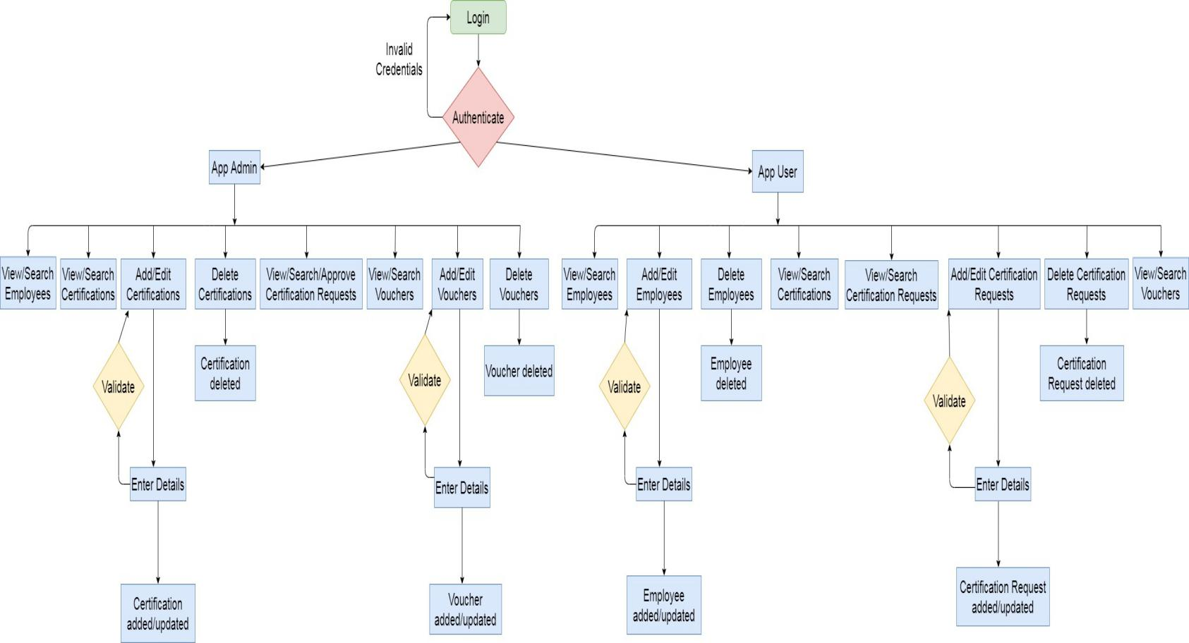

Fig 1.6-Flow Chart

**Use Case Diagram:**

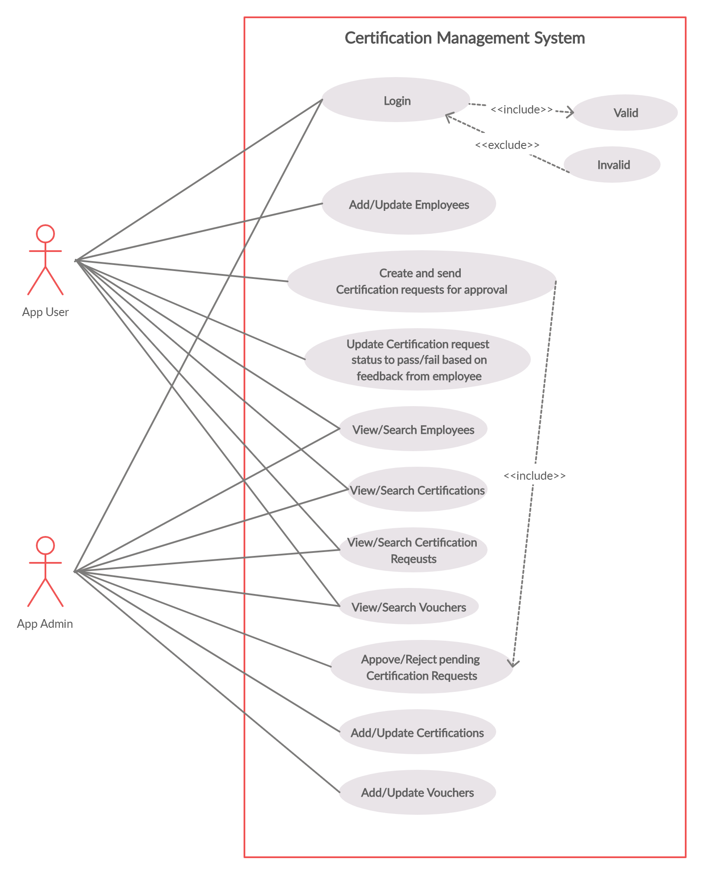

Fig 1.7-Use case diagram

**Screenshots:**

1. **App User**

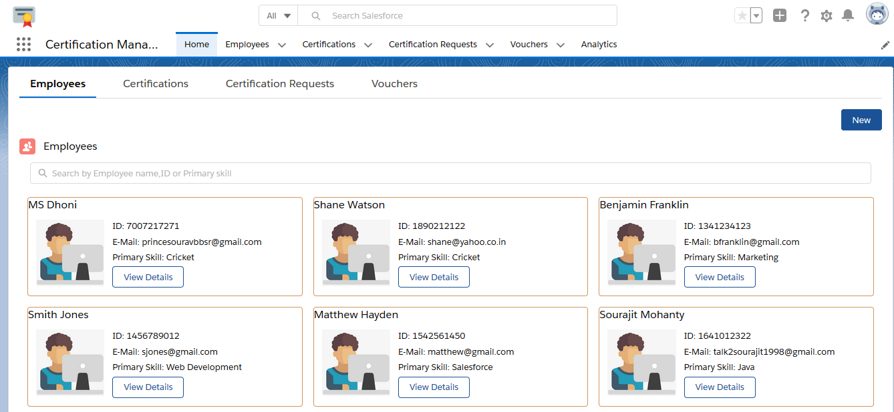

Fig-2.1.1: App User Home page (Employee tab is activated by default)

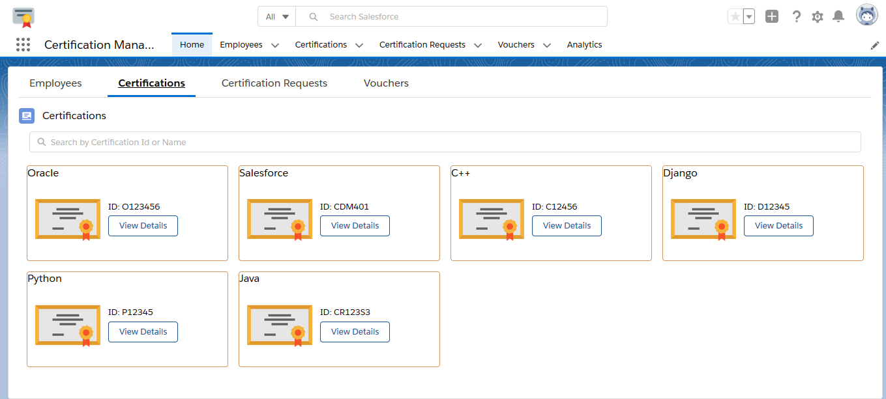

Fig-2.1.2: App User Home page (Certification tab has been activated here)

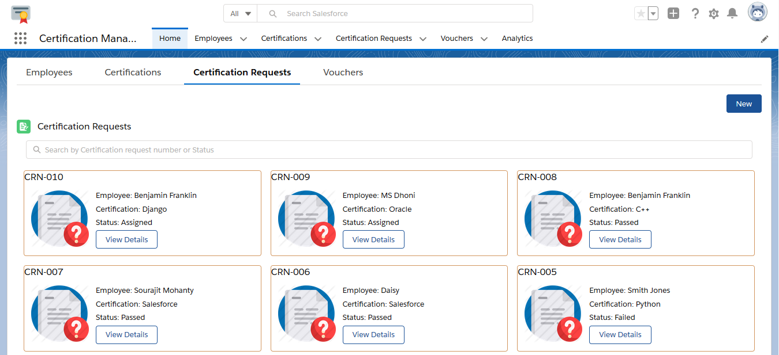

Fig-2.1.3: App User Home page (Certification Request tab has been activated here)

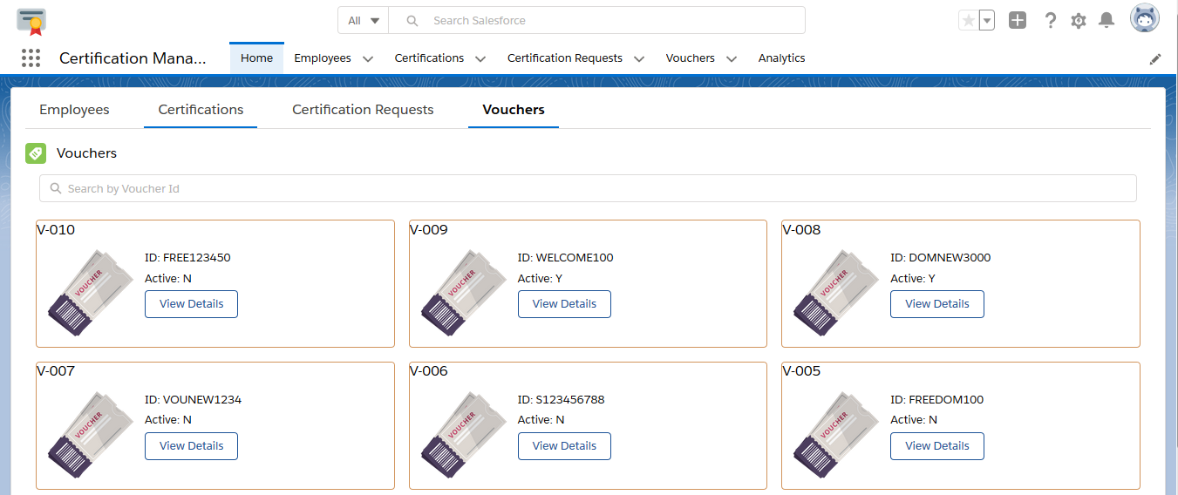

Fig-2.1.4: App User Home page (Voucher tab has been activated here)

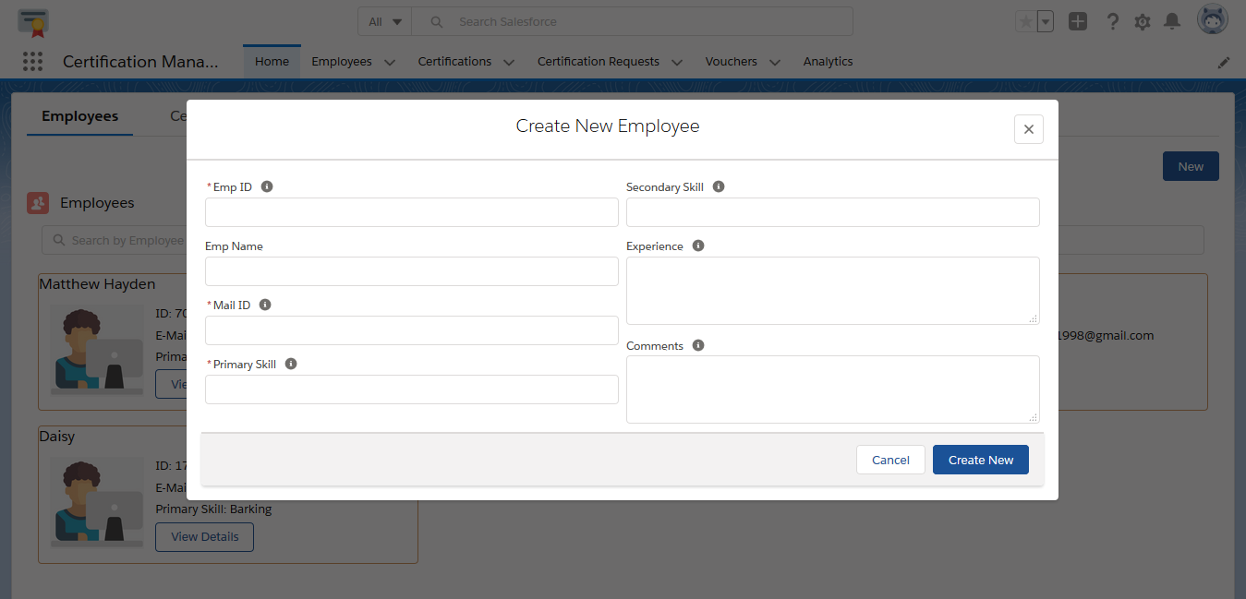

Fig-2.1.5: App User-Create new Employee page

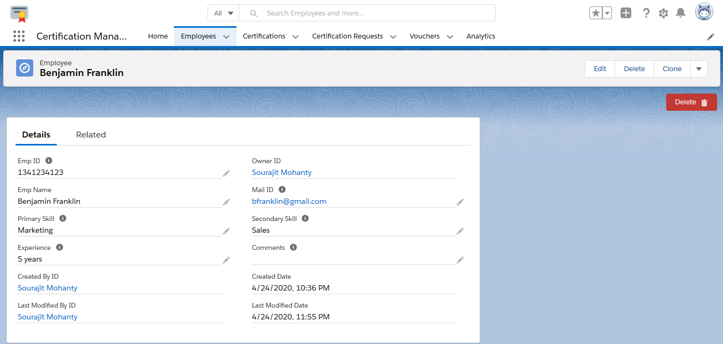

Fig-2.1.6: App User-Employee record page

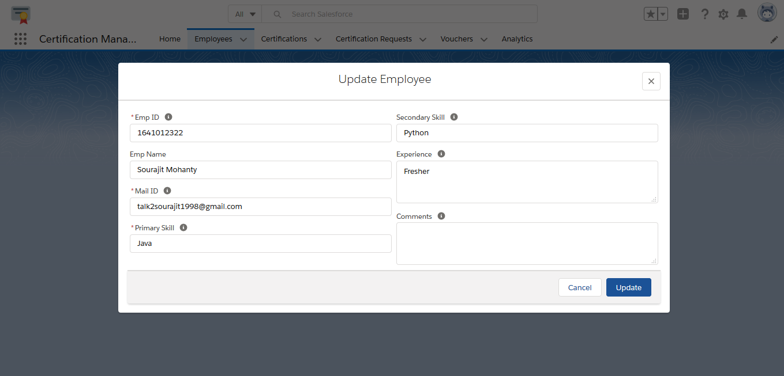

Fig-2.1.7: App User-Employee record Edit page

1. **App Admin**

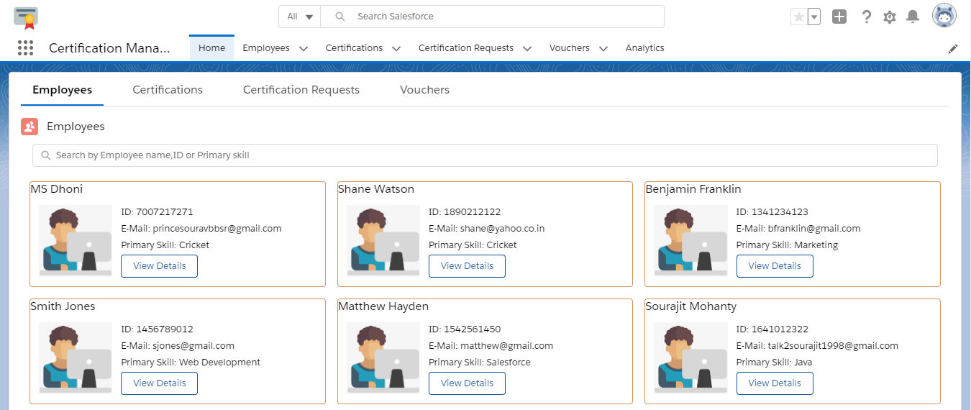

Fig-2.2.1: App Admin Home page (Employee tab is activated by default)

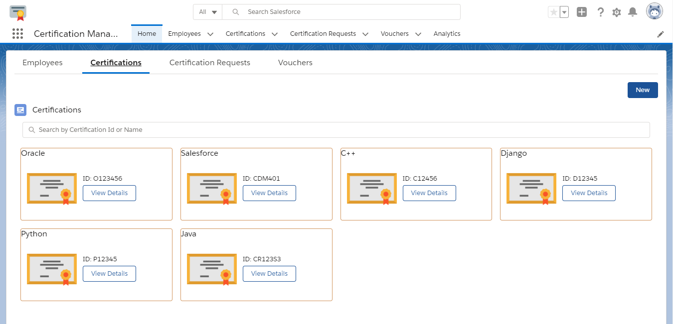

Fig-2.2.2: App Admin Home page (Certification tab has been activated here)

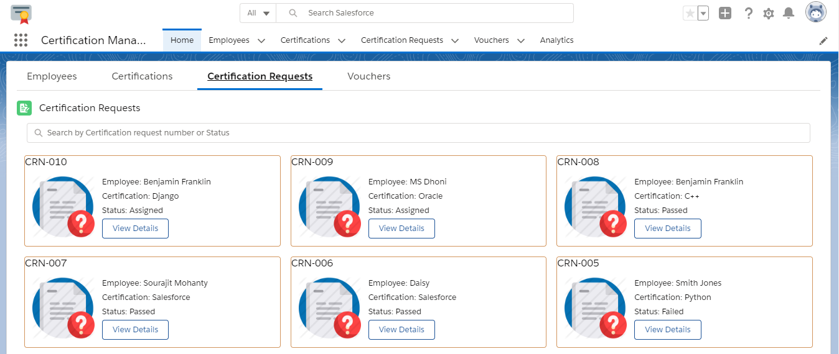

Fig-2.2.3: App Admin Home page (Certification Request tab has been activated here)

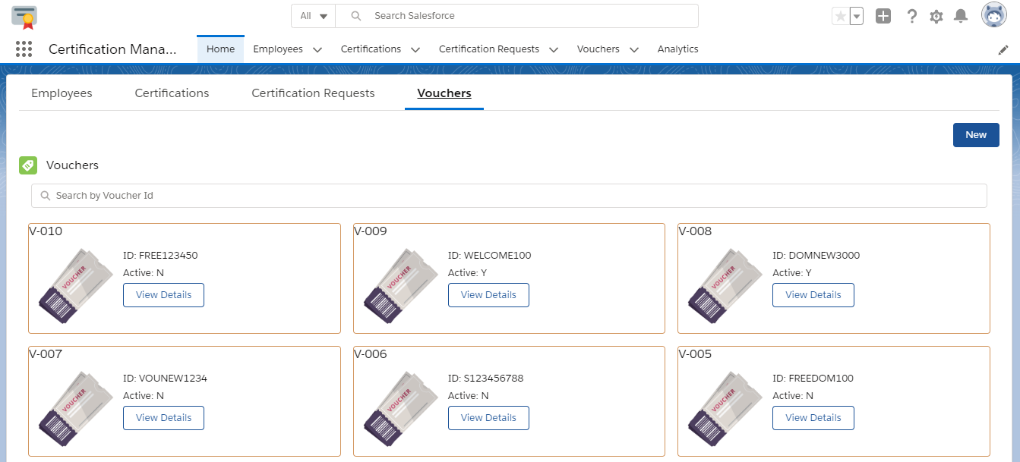

Fig-2.2.4: App Admin Home page (Voucher tab has been activated here)

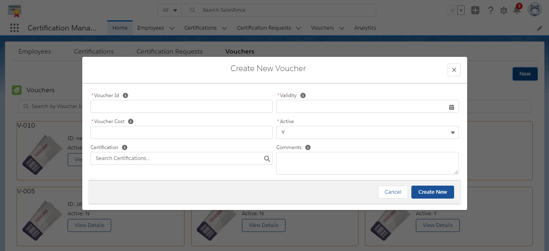

Fig-2.2.5: App Admin-Create new Voucher page

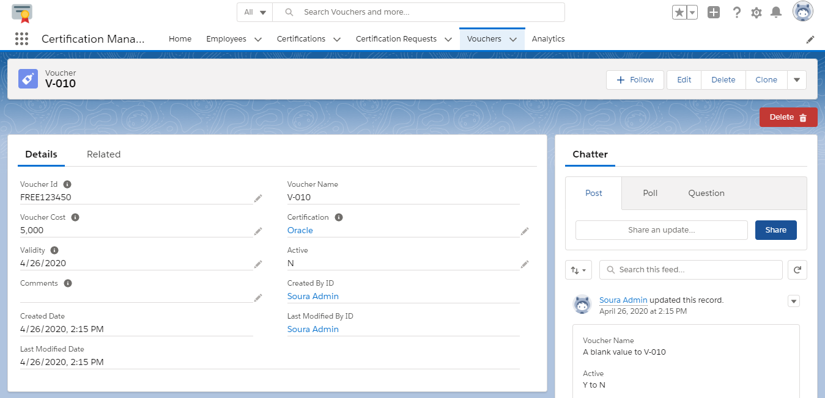

Fig-2.2.6: App Admin-Voucher record page

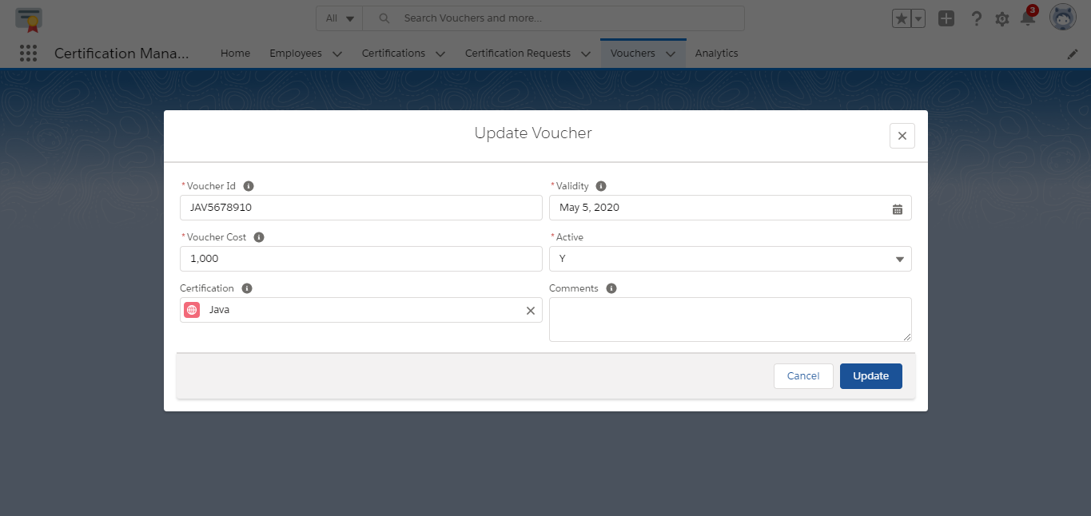

Fig-2.2.7: App Admin-Voucher record Edit page

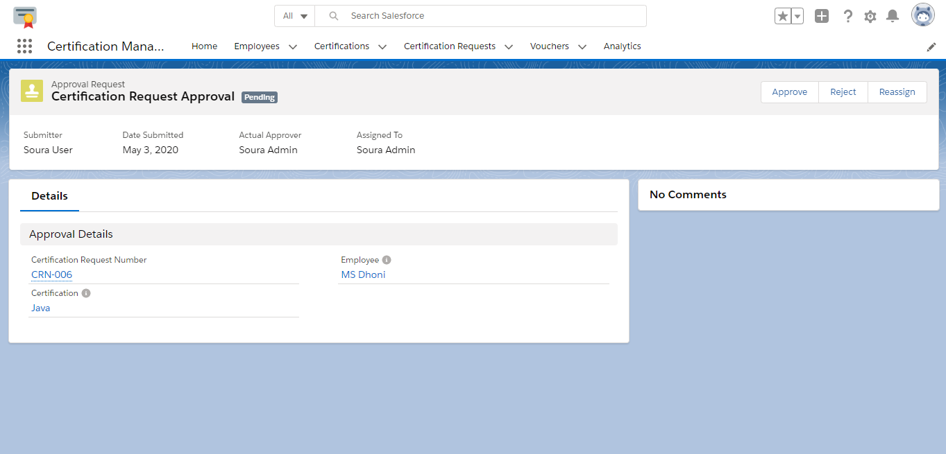

Fig-2.2.8: App Admin-Certification request approval/reject page

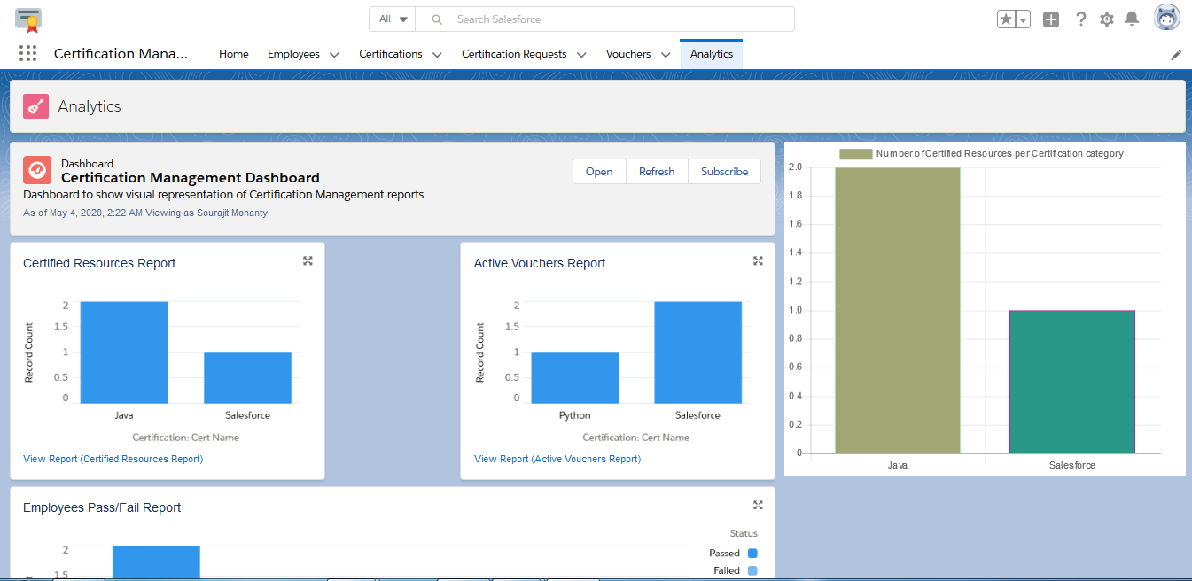

Fig-3.1: Analytics tab-accessible by both User and Admin which displays various

reports graphically

**Object Description:**

1. **Employee** : This object stores all the details of practice members pursuing a Salesforce certification exam.

Fields:

Emp Id : Text

Emp Name : Text

Mail Id : Email

Primary Skill : Text

Secondary Skill : Text

Experience : Text Area

Comments : Text Area

Triggers:

2. **Certification** : This object stores all details of Salesforce certification exam.

Fields:

Cert Id : Text

Cert Name : Text

Comments : Text Area

Triggers:

3. **Certification Request** : This object stores all details of the Certification-Voucher request raised by the App User for the Employee.

Fields:

Certification Request Number : Auto-Number

Certification : Master-Detail

Employee : Master-Detail

Voucher : Lookup

Due Date : Date

Status : Picklist

Comments : Text Area

Triggers:

UniqueCertificateVoucherRequestTrigger : To prevent duplicate Certification -Voucher requests from being raised for the same Employee and assign active vouchers to Certification requests once they have been approved by App Admin.

RejectionCommentsMandatory : To ensure that comments are given in case request is rejected by App Admin.

4. **Voucher**: This object stores all details of vouchers for all associated Certifications offered by Salesforce.

Fields:

Voucher Name : Auto-Number

Voucher Id : Text

Voucher Cost : Number

Certification : Lookup

Validity : Date

Active : Picklist

Comments : Text Area

Triggers:

AutomaticVoucherAssignTrigger : To automatically assign vouchers to existing approved Certification Requests on first-come first-serve basis when new vouchers are added to the system.

# Validations:

1. Voucher cost cannot be negative.
2. Voucher validity should not be less than current date.
3. Certification request due date should not be less than current date.
4. Vouchers should be assigned to the Certification requests only if the request's due date has not passed.
5. Only vouchers which are active and have validity greater or equal to Certification request's due date should be assigned.
6. App User should not be able to raise same certification voucher request again if one already exist in the system.
7. App User should not be able to add new certification voucher request in system if there is any pending request already existing for that employee.
8. Comments should be mandatory in case request is rejected by App Admin.
9. Only unused voucher should be assigned to the Certification request.
10. Voucher should be exact 10 characters long and unique.
11. If an employee gets passed/failed in any certification then system should not allow App User to raise same certification request for that employee again.

# Assumptions:

However, we have made a few assumptions with respect to the application, which are:

1. Certification request's due date is the date on which the exam is supposed to take place.

2. After the Certification request has been assigned a voucher ie. once its status has changed to ‘Assigned’, it is assumed that the Voucher code has been sent to the employee for redemption.

3. The voucher is deactivated by Admin once the voucher’s validity is over.The same cannot be redeemed by Employee after the voucher’s validity has expired.

4. All vouchers need to have a Certification assosciated with them inorder to be assigned to a Certification request.